SE4041 – Mobile Application Design and Development
Assignment 01 – Documentation & Viva Pack
Community Services and Local Marketplace Mobile Application

Brand wordmark: යාළුway | Help nearby. Trade nearby. Trust nearby.

Faculty of Computing
BSc (Hons) in Information Technology | Year 4 – Semester 1 & 2
Sandaruwan W J – IT22294548
Technology: Kotlin | XML layouts | Android Studio | Room (SQLite)
GitHub: https://github.com/jihansandaruwan/yaluway
Figma: https://www.figma.com/design/0UVq1JYisRj6rl7UoadYFi/Untitled
SDLC covered: Planning → Requirements → Design → Development → Testing

Contents
1. Overview of the Application
2. Features and Functionalities
3. Development Implementation
4. Challenges Faced
5. Application Screenshots
6. Testing Procedures and Results
7. GitHub Repository
8. How to Run the Application for Viva
This report follows the official Documentation marking scheme (Overview, Features, Challenges, Screenshots, Testing) and keeps the same visual style as the Phase 01 proposal and UI prototype submissions.

1. Overview of the Application
යාළුway (Yaluway) is a Kotlin Android application built for the assigned domain Community Services and Local Marketplace (registration last digit 8). The name combines යාළු (friend) and way (path). The tagline is Help nearby. Trade nearby. Trust nearby.
The application is a hyperlocal neighbourhood notice-board. People in the same Sri Lankan city cluster can ask for help, offer a local skill, or share an item (lend, borrow, donate, or free). It is not a payment app, chat app, or island-wide classified site. Discovery is area-first.
The implemented Android app follows the approved Figma prototype: Splash, Login, Register, three onboarding slides, Home with bottom navigation, category boards, post detail, create/edit post, saved items, incoming/sent requests, and Profile.

1.1 Problem addressed
Community help and local trade in Sri Lanka still happen on WhatsApp groups and Facebook Marketplace. Those channels are noisy, hard to search, weak on trust, and not designed for both mutual aid and neighbour trading in one place. යාළුway puts Help, Services, and Marketplace into one structured mobile path.

1.2 Target audience
- University students who need or share everyday items (textbooks, kettle, tutor).
- Residents who need urgent or practical help (blood request, plumber, jumper cables).
- Home-based providers who offer a nearby skill (tutor, cleaner, cook).

1.3 Scope of this build
In scope (implemented) | Out of scope (not in this MVP)
Register, login, session restore | Cloud / internet backend
Create, edit, delete own posts | Online payments
Save post and send request | In-app chat
Accept / decline request + share phone | GPS live map
Nearby-area post filter | Admin dashboard
Room SQLite + form validation | Push notifications
Unit tests for validators and queries | Play Store release

1.4 Technology stack
Layer | Choice | Why
Language | Kotlin | Required by SE4041
UI | XML layouts + Material buttons | Same pattern as lab Activities / Fragments
Navigation | Activities, Fragments, bottom nav, FAB | Clear student architecture
Database | Room 2.6.1 on SQLite (yaluway.db) | Local persistence, no server
Images | Gallery picker copied to app files | Each user/post can have own photo
Onboarding | ViewPager2 with slide animation | Swipe between intro pages
Tests | JUnit unit tests | Validators and nearby-area query

2. Features and Functionalities
Features are justified against the assigned domain and the later Kotlin marking points: layouts, views, interactivity, core functionality, and database.

2.1 Feature list
Feature | What the user can do | Why it is needed
Create account | Name, email, password, Sri Lankan city | Each neighbour has their own saved account
Form validation | Red errors; Create stays off until valid | Stops numbers-in-name and fake areas
Login / session | Reopen app still logged in | Account is stored, not forgotten on close
Onboarding slideshow | Swipe Help → Services → Marketplace | Teaches the 3-in-1 model
Nearby Home feed | Sees posts near own city cluster | Negombo user does not see Kandy posts
Help / Services / Market | Open category boards | Matches the assigned 3 modules
Create post | Photo, type, mode, title, city, 10-digit phone | Publish a real neighbourhood listing
Lend / Borrow / Donate / Free | Shown only for Marketplace, with help text | Neighbour sharing, not only selling
Send request | Neighbour asks the owner | Structured contact instead of random chat
Accept / Decline | Owner shares phone only after accept | Trust: number is not public at first
Save post | Keep a listing for later | User can return to useful posts
My posts / Profile | Edit, delete, change photo and area | Account ownership and CRUD

2.2 Request procedure
This is the main social flow of the app and should be demonstrated in the viva.
- A neighbour opens a post that is not theirs and taps Send request.
- The request is stored as PENDING in the Room requests table.
- The owner sees it under Me → Requests, or on their post as View requests.
- Accept: the requester then sees the owner’s phone number and can call to arrange pickup.
- Decline: the requester sees Declined. No phone number is shown.
Because there is no server, two accounts on the same phone are used to show this: log out, register a second person, send a request, then log back in as the owner.

2.3 Nearby area logic
Posts are filtered by the city saved on the logged-in account. Exact GPS is out of scope. Cities are grouped into local clusters so a Negombo user also sees Ja-Ela / Katunayake, while a Nugegoda user sees the Colombo cluster, and a Kandy user sees Kandy posts only.
The user can change city later from Me → Area settings. The Home title then reads “Posts near [city]”.

2.4 Marketplace modes
- Lend — I own the item. You borrow it and must return it.
- Borrow — I need to use someone else’s item for a short time.
- Donate — I give the item away. They keep it.
- Free — Anyone can take it. No money and no return.
These chips appear only when the post type is Marketplace. Help and Services hide them.

3. Development Implementation
This section maps the Kotlin build to the development marking scheme so the viva panel can see layouts, views, interactivity, functionality, and database.

3.1 Layout selection
Screen | Layout | Reason
Splash / Login / Register | ScrollView + LinearLayout | Simple forms, keyboard safe
Onboarding | ViewPager2 + page XML | Swipe slideshow
Home | NestedScrollView + RecyclerView | Banner, chips, then post list
Post lists | RecyclerView + item_post.xml | Reuse one card for Home / My posts / Saved
Create post / Detail | ScrollView + LinearLayout | Long form and action buttons
Main shell | Fragment container + bottom nav + FAB | Home / My posts / Me

3.2 UI components
- MaterialButton for primary actions (Log in, Create account, Publish, Send request).
- EditText and AutoCompleteTextView for typed fields and Sri Lankan city picker.
- RadioButton chips for Help / Services / Marketplace and Lend / Borrow / Donate / Free.
- ImageView for brand, post photos, and profile avatar.
- BottomNavigationView and yellow FAB for the main app chrome.
- RecyclerView adapters for posts and incoming/sent requests.

3.3 User interactivity
- Live red validation: Create account and Publish stay disabled until the form is correct.
- Onboarding page transformer (fade + scale) when moving from one slide to the next.
- Search box on Home filters the nearby list as the user types.
- Save toggles; Send request becomes waiting / accepted / declined.
- Tap profile photo or Choose a photo to pick a gallery image.
- Accept / Decline on the owner’s request inbox.

3.4 Database integration
Room stores everything on the device in yaluway.db. There is no remote API. A SharedPreferences backup also keeps user accounts so a schema reset does not silently wipe logins.
Table | Purpose | Key fields
users | Accounts | email (PK), username, area, password, avatarPath
posts | Listings | title, category, area, contact, mode, imagePath, ownerEmail
saved_posts | Bookmarks | email + postId
requests | Ask / accept flow | requesterEmail, postId, status, createdAt

Session email is stored in SharedPreferences. Splash restores the user from Room and skips Login when a valid session exists.

3.5 Validation rules
Field | Rule
Full name | Letters, spaces and simple punctuation only. Numbers rejected.
Email | Must look like name@domain.lk / .com
Password | At least 8 characters; confirm must match
Area | Must be a city from the Sri Lankan list (type-to-search)
Post title | At least 3 characters and must contain a letter
Description | At least 10 characters
Phone | Exactly 10 digits, starting with 0

4. Challenges Faced
The assignment asks for a critical discussion of challenges and how they were solved. The points below are from the real build, not theoretical risks.

4.1 Xiaomi / Samsung USB install
Running on a physical phone failed at first with INSTALL_FAILED_USER_RESTRICTED (Installation via USB is disabled) on Xiaomi, and later the Galaxy A16 appeared in Windows as a file device but not in Android Studio until USB debugging was turned on. Solution: enable Developer options, USB debugging, and on Xiaomi also Install via USB plus a Mi account. On Samsung, File transfer + Allow USB debugging was enough.

4.2 Same picture on every profile and post
Early screens used one hardcoded drawable, so every person and every post looked the same. Solution: ImageBinder copies a gallery URI into app storage. Users and posts store imagePath. Seed posts use different drawable names so demo listings are not identical.

4.3 Accounts disappearing after close / rebuild
Room fallbackToDestructiveMigration wiped the database when the schema changed, so the same email and password looked “wrong” after a rebuild. Solution: persist users in Room and also write a SharedPreferences backup. On startup, if the users table is empty, accounts are restored. Session writes use commit() so a quick app close does not lose the logged-in email.

4.4 Unclear Marketplace options
Lend, Borrow, Donate and Free were shown for every post type, so users did not know what to pick. Solution: show those chips only for Marketplace, and put one-line help under the selected mode.

4.5 Area used as a free-text name
A full name with numbers could be typed into Area, which broke nearby filtering. Solution: AutoCompleteTextView over a Sri Lankan city list. Unknown text is rejected in red.

4.6 Nearby posts without GPS
The brief is hyperlocal, but a full map API is outside the student MVP. Solution: city clusters (Negombo coast, Colombo metro, Kandy, Galle, and others). Home and category lists filter with PostQuery + SriLankaAreas.isNearby().

5. Application Screenshots
The screens below are the Figma frames that the Kotlin XML implementation follows. In the viva the same flows are shown live on the phone / emulator. Extra phone screenshots can be pasted under each figure if needed.

5.1 Entry: Splash, Login, Register
Splash shows only the brand. Login is for a returning neighbour. Register collects name, email, password, confirm password, and a selectable Sri Lankan city. The Create account button stays disabled until every field is valid. Red text appears under a wrong field.
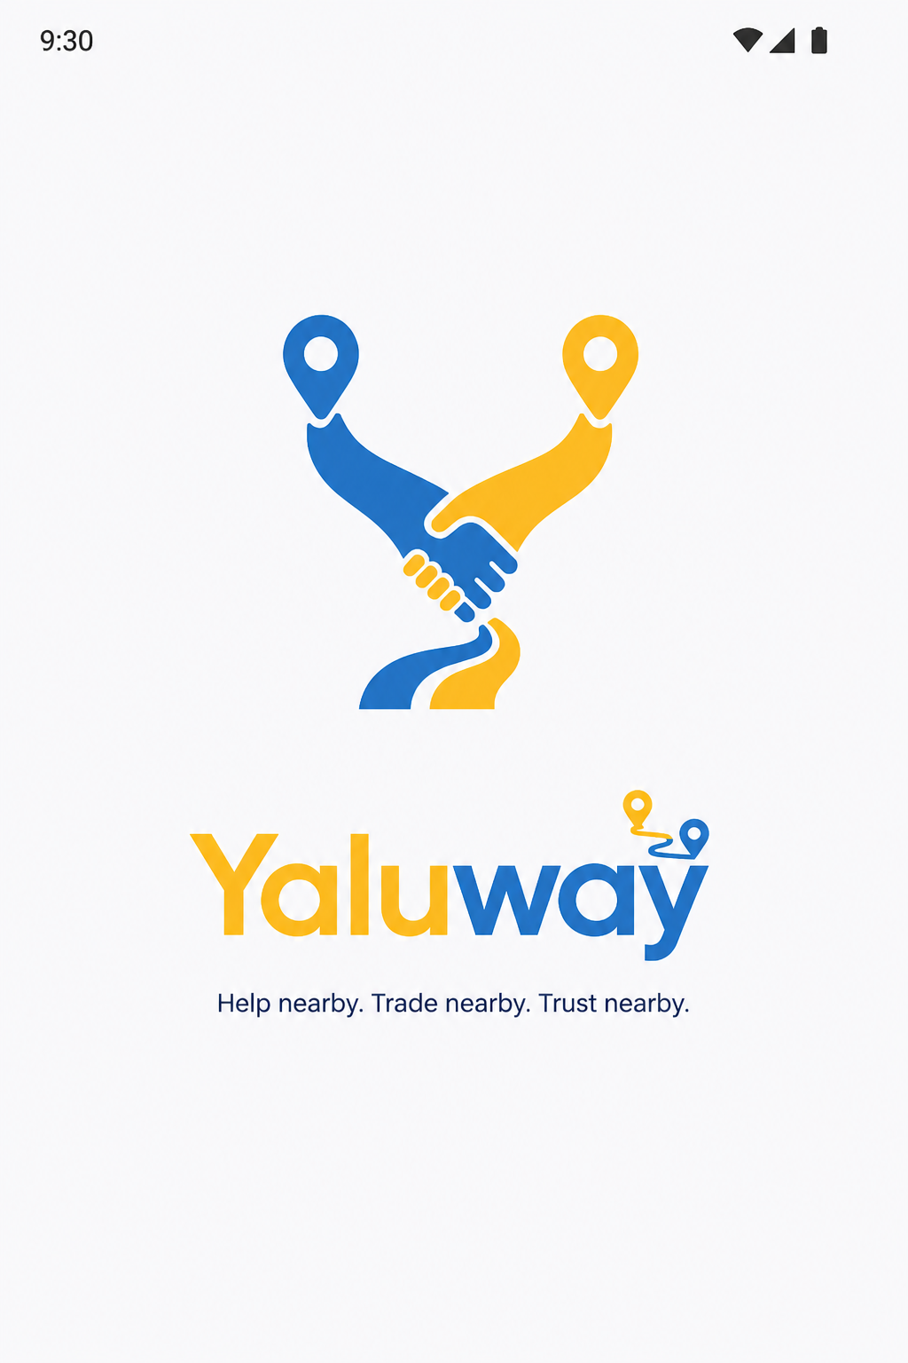 | 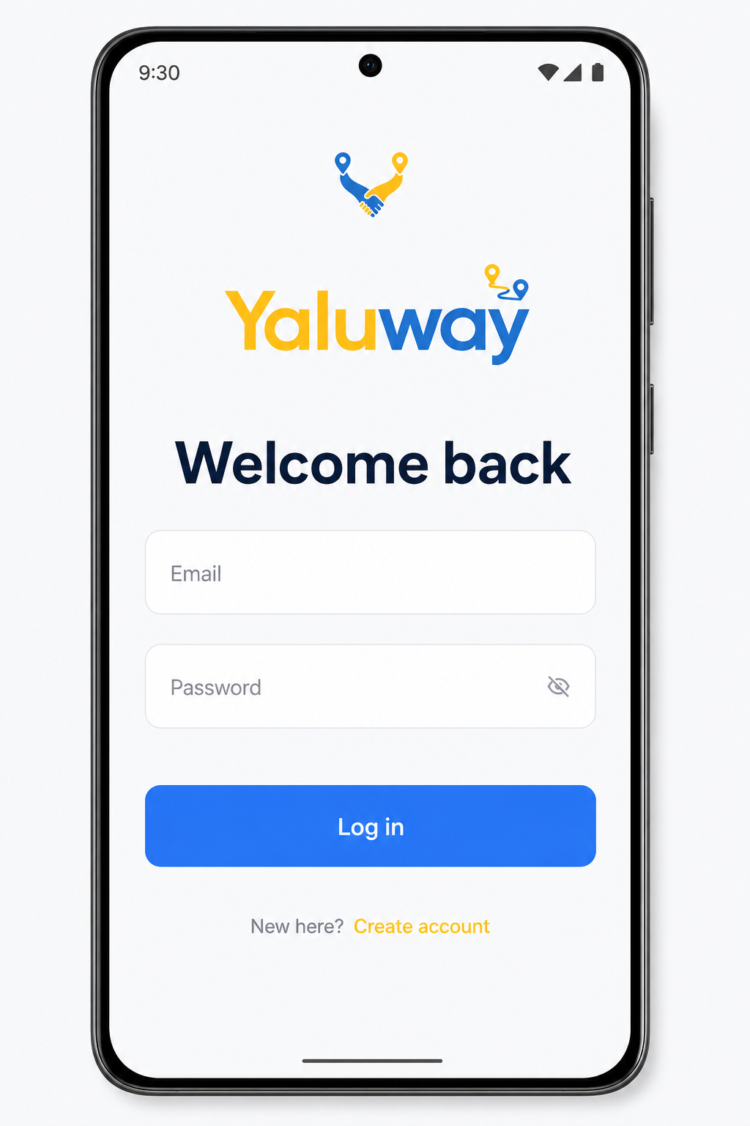

Figure 1. Splash (left) and Login (right).
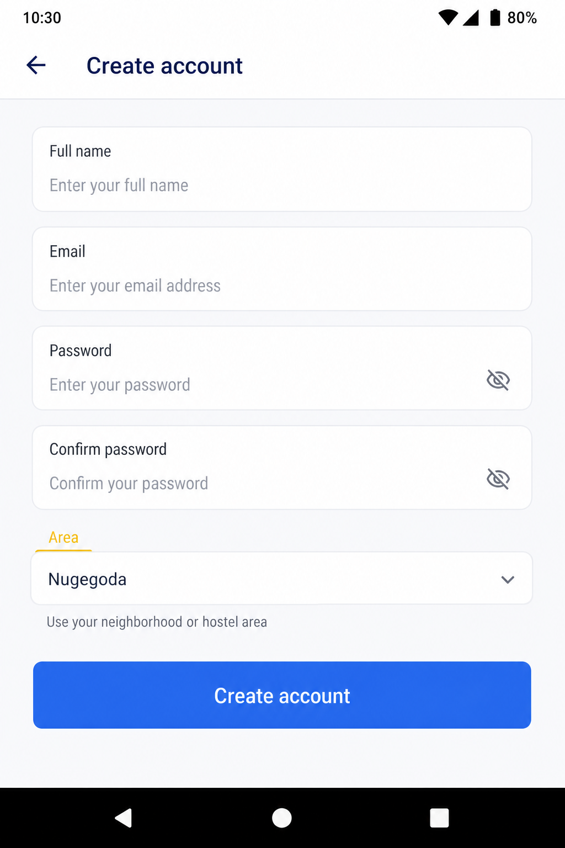
Figure 2. Create account — validated form with area picker.

5.2 Onboarding slideshow
After first register, three slides explain Help, Services, and Marketplace. The user can swipe or tap Next. The last slide is Get started.
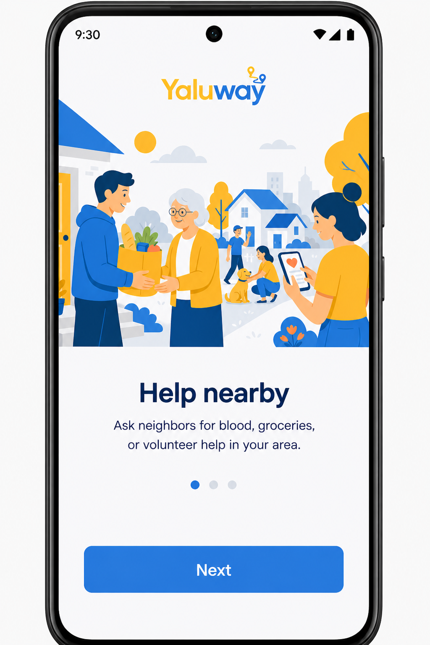 | 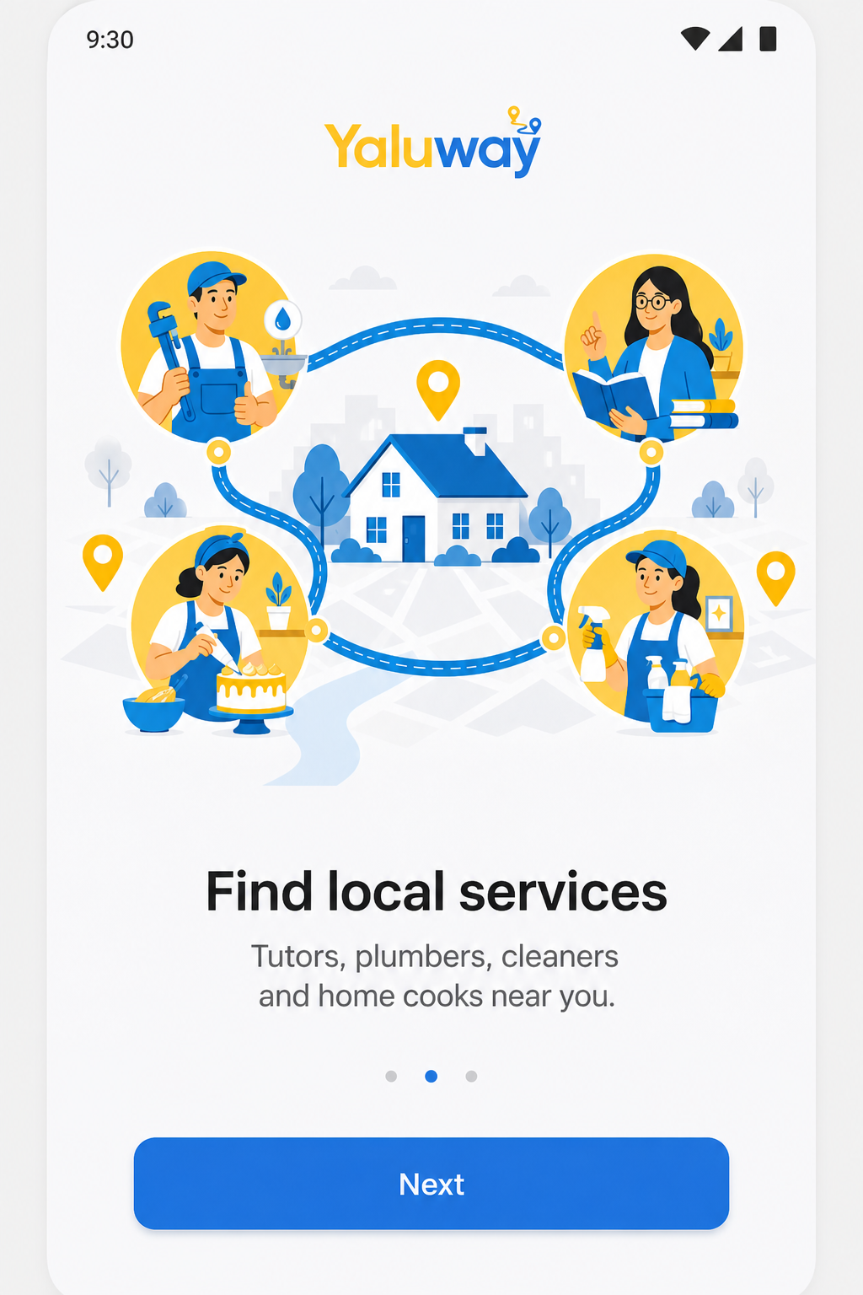

Figure 3. Onboarding — Help nearby (left) and Find local services (right).
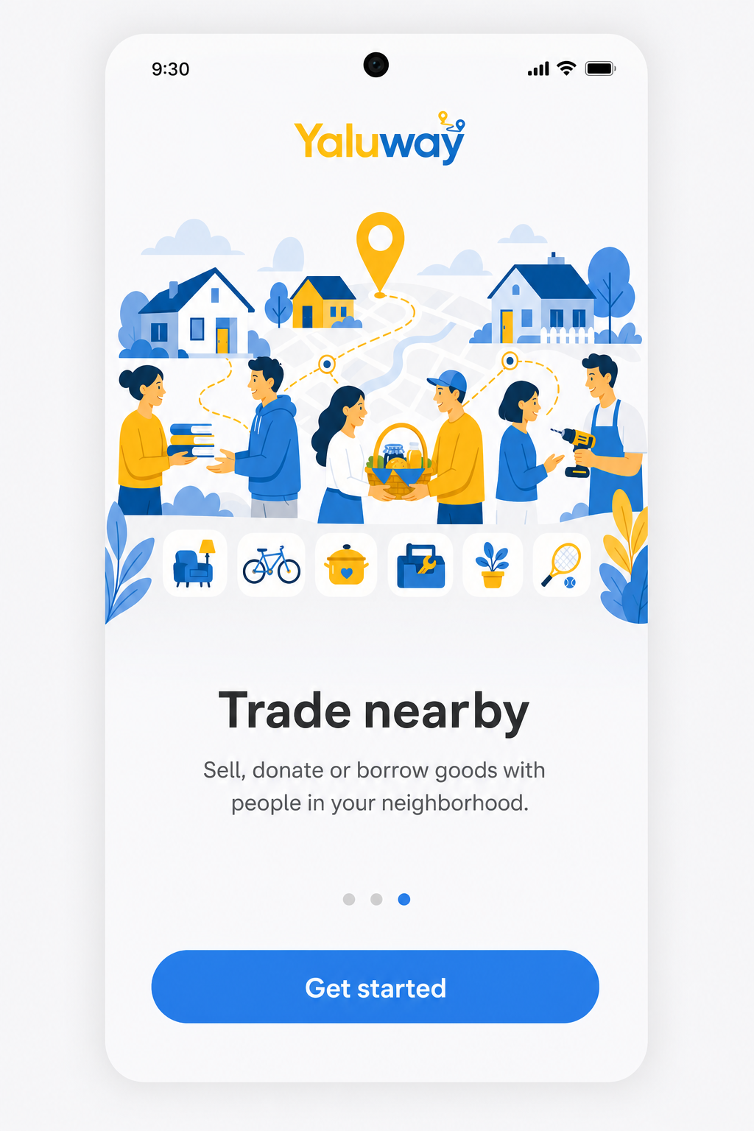
Figure 4. Onboarding — Trade nearby.

5.3 Home and category boards
Home shows the signed-in city, a search box, three module cards, and a nearby post list. Help, Services, and Marketplace open filtered boards. Cards show area, type, and time.
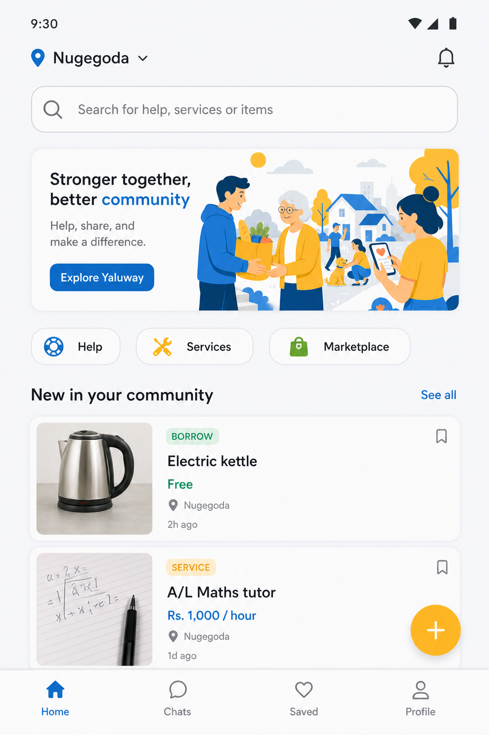 | 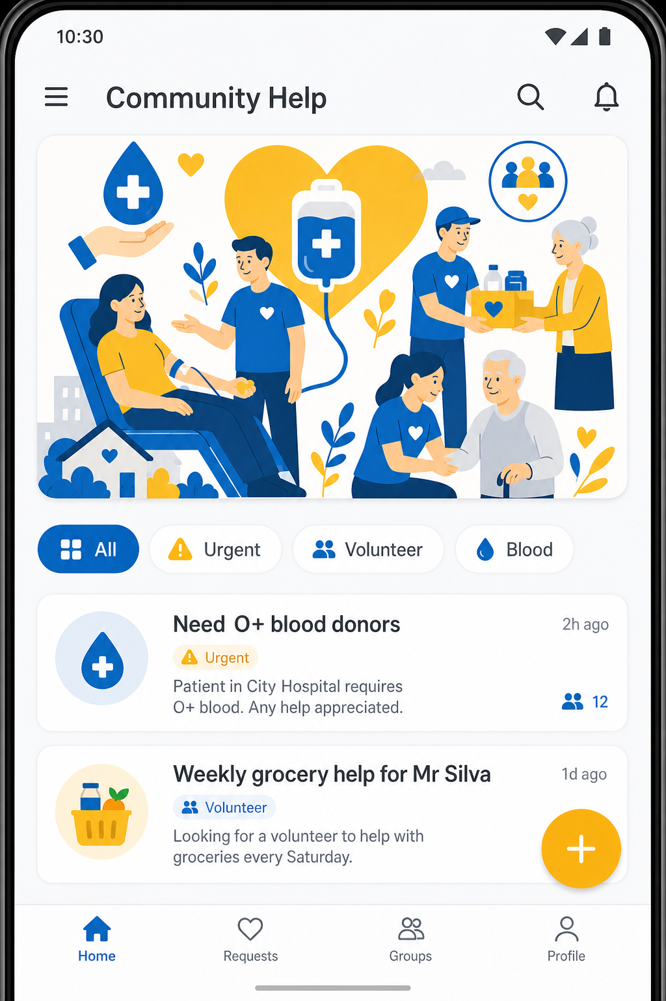

Figure 5. Home (left) and Help board (right).
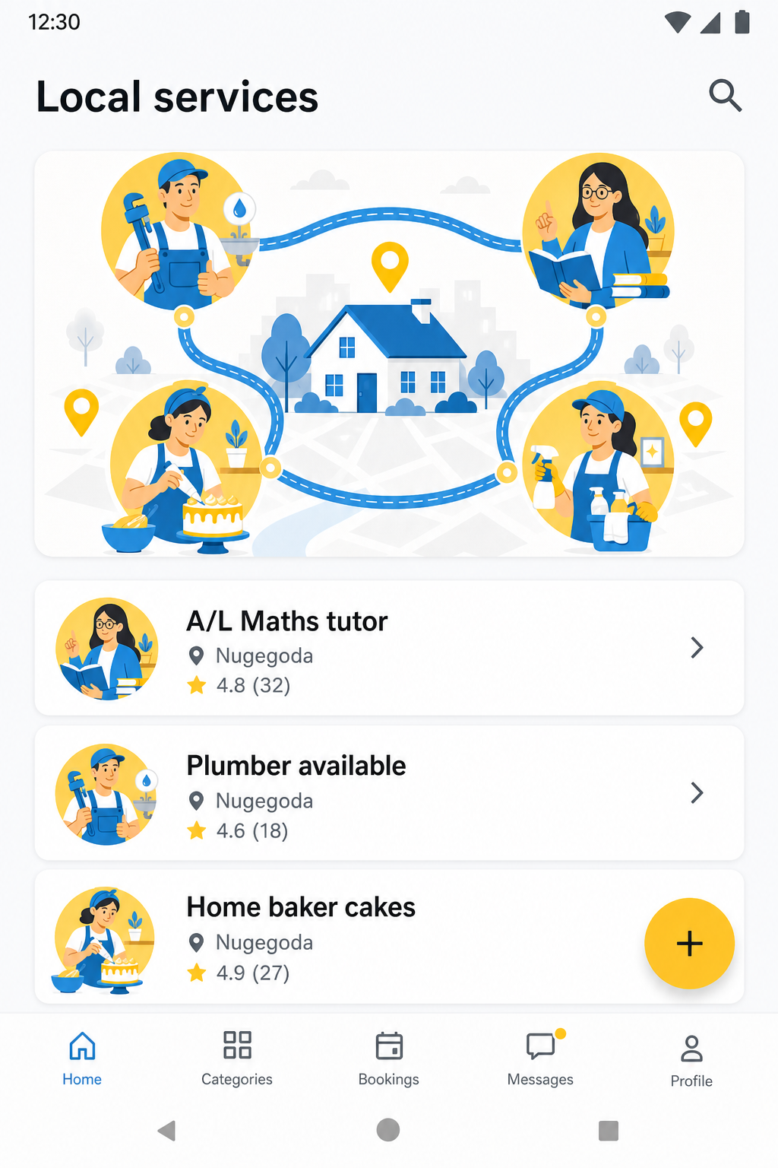 | 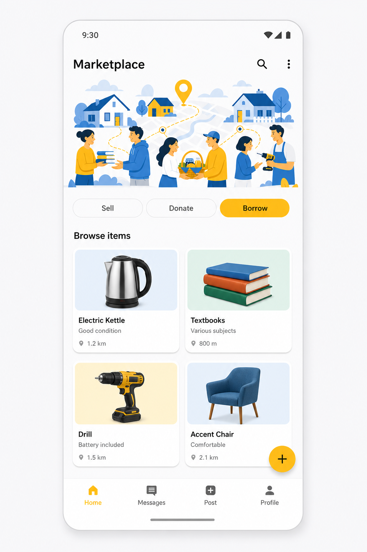

Figure 6. Services (left) and Marketplace (right).

5.4 Post detail and create post
Post detail shows the listing photo, description, and actions. A neighbour can Save or Send request. The owner sees Edit, Delete, and View requests. Create post asks for type, Marketplace mode (if needed), photo, title, description, city, and a 10-digit phone.
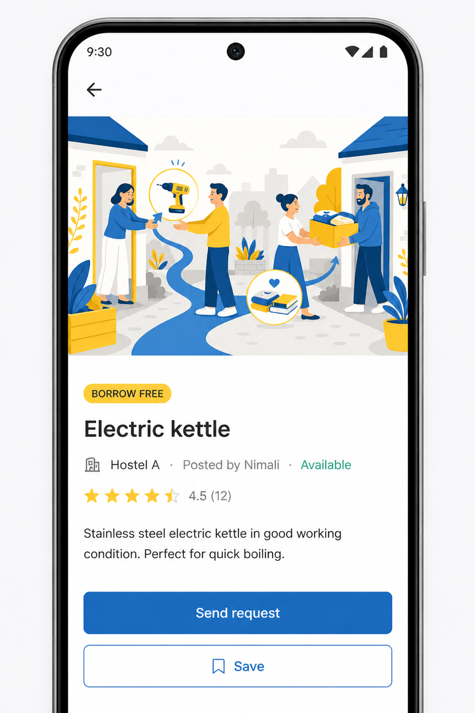 | 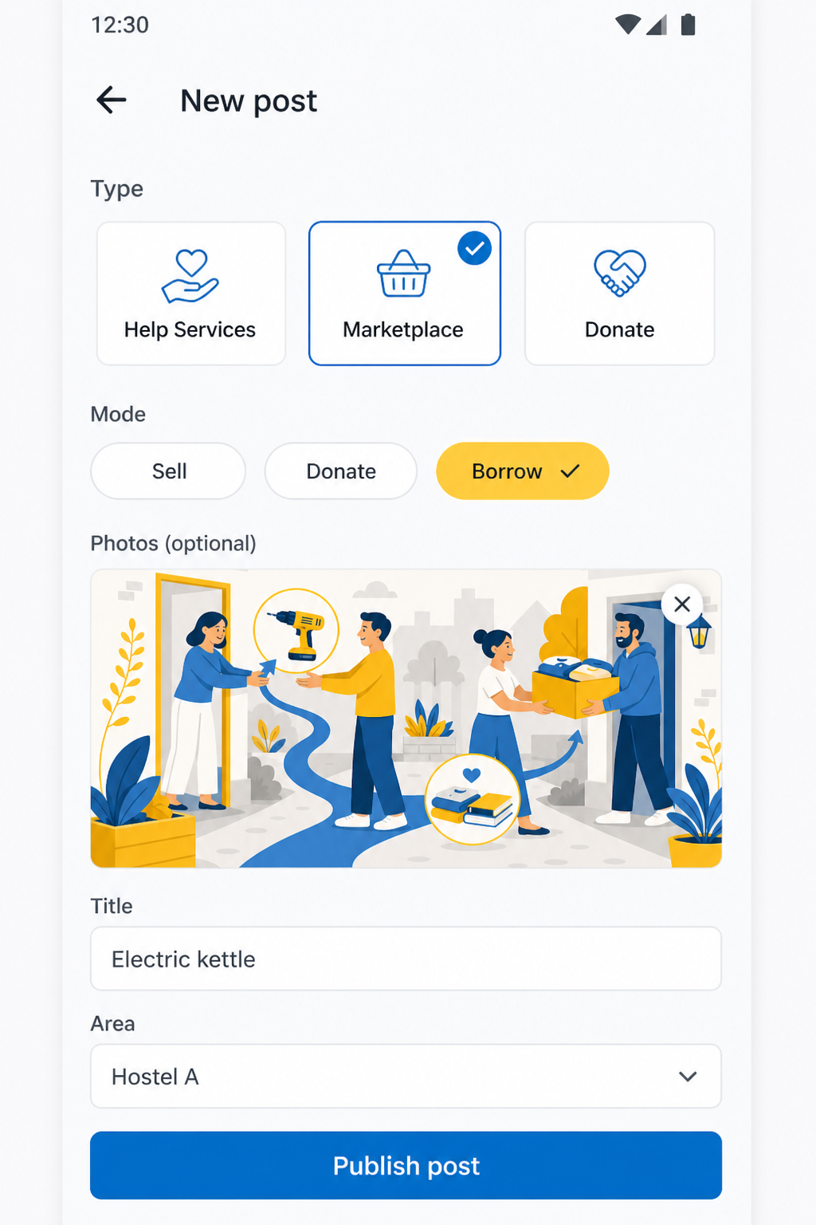

Figure 7. Post detail (left) and Create post (right).

5.5 Profile and empty state
Profile shows the user’s photo (tap to change), post/saved counts, Requests inbox, saved items, area settings, and logout. Empty My posts uses a friendly illustration so a new account is not a blank screen.
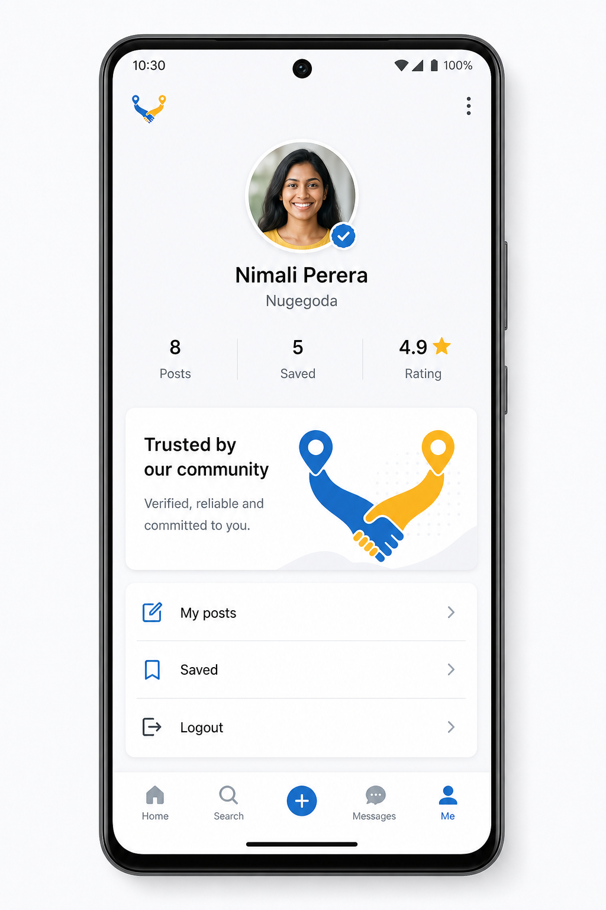 | 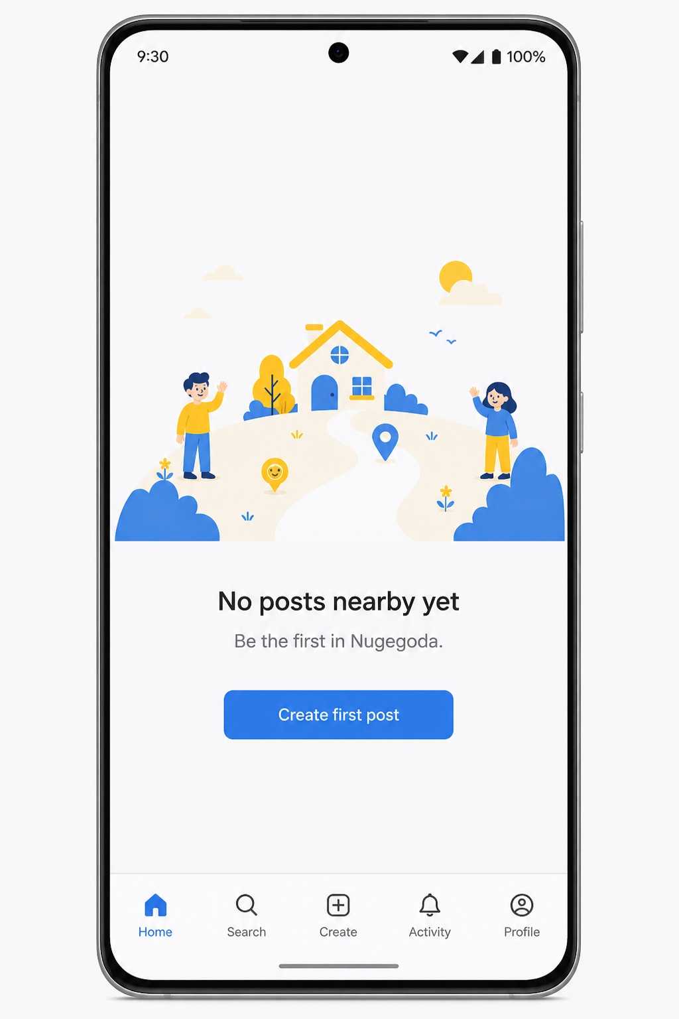

Figure 8. Profile (left) and empty My posts (right).

6. Testing Procedures and Results
Testing covers unit tests (JUnit) and integration-style checks on the running app (emulator and physical phones: Redmi / Galaxy A16).

6.1 Unit testing
Unit tests live in app/src/test and do not need a device. They check validation and the nearby-area query used by Home.
Test class | What it proves | Result
ValidatorsTest.fullNameRejectsNumbers | Kasun123 is invalid; Kasun Perera is valid | Pass
ValidatorsTest.emailMustLookValid | kasun@yaluway.lk valid; not-an-email invalid | Pass
ValidatorsTest.passwordNeedsEightCharacters | short rejected; 8+ accepted | Pass
ValidatorsTest.phoneMustBeTenDigits | 0712345678 valid; 07123 invalid | Pass
ValidatorsTest.areaMustBeASriLankanCity | Nugegoda valid; Kasun123 not an area | Pass
PostQueryTest.searchFindsArea | Search “nugegoda” returns the blood post | Pass
PostQueryTest.categoryFilterWorks | Services filter keeps service posts | Pass
PostQueryTest.urgentChipKeepsBloodPost | Urgent chip keeps the blood request | Pass
PostQueryTest.negomboUserSeesNearbyCoastPosts | Negombo feed is coastal, not Kandy | Pass
PostQueryTest.kandyUserDoesNotSeeNegomboPosts | Kandy user does not see Negombo | Pass

How to run: Android Studio → Gradle → app → Tasks → verification → test, or :app:testDebugUnitTest.

6.2 Integration / manual testing
ID | Scenario | Expected | Result
IT-01 | Register valid account | Session starts; onboarding then Home | Pass
IT-02 | Name with a number | Red error; Create account stays off | Pass
IT-03 | Area typed as a person name | Red error; must pick a city | Pass
IT-04 | Close app and reopen | Still logged in, or same password works | Pass
IT-05 | Log in as Negombo | Home shows Negombo / Ja-Ela posts | Pass
IT-06 | Log in as Kandy | Home shows Kandy posts only | Pass
IT-07 | Create Marketplace post | Photo + 10-digit phone required; modes explained | Pass
IT-08 | Second account sends request | Owner sees PENDING in Requests | Pass
IT-09 | Owner accepts | Requester sees phone number | Pass
IT-10 | Owner declines | Requester sees Declined | Pass
IT-11 | Save / unsave | Saved list updates; count on Profile updates | Pass
IT-12 | Edit / delete own post | List and detail stay consistent | Pass
IT-13 | Change profile photo | Home avatar and Profile update | Pass

6.3 Test evidence notes
Unit tests are code evidence. Manual tests were run on the emulator and on a Galaxy A16 after USB debugging was enabled. Xiaomi install required Install via USB. For the viva, the same scripts can be re-run live: two accounts, one request, nearby filter.

7. GitHub Repository
The brief requires the complete application via GitHub and a public repository link in this report. The project folder to upload is Assigment 01 (rootProject.name = yaluway), not the older tutorial folder.
Repository URL (replace with the live public link before printing):
https://github.com/jihansandaruwan/yaluway
- Keep the repository public for the viva.
- Include this documentation file and the Kotlin source.
- Do not upload app/build, .gradle, or local.properties.
- In the viva: open the GitHub page, show the package com.example.yaluway, then run the app.

7.1 Suggested commit story
The brief asks for regular commits. If the work was done locally first, still make several clear commits before the viva rather than one dump, for example: project setup, auth screens, Room database, post CRUD, requests, validation, nearby filter, documentation.

8. How to Run the Application for Viva
- Open Android Studio → Open → D:\MAD\Assigment 01.
- Wait for Gradle sync. Run on emulator or a phone with USB debugging.
- Create a first account (example: Negombo). Walk Splash → Register → Onboarding → Home.
- Show nearby posts, open a post, create a Marketplace listing with a photo and 10-digit phone.
- Log out. Create a second account in the same city. Send a request on the first user’s post.
- Log back in as the owner. Open Me → Requests. Accept and show that the phone appears.
- Log in as a Kandy account to show the feed change.
- Open GitHub on the browser and point to Activities, Room entities, and unit tests.

8.1 Documents to take
- This documentation report (print or PDF).
- Phase 01 proposal: IT22294548 Sandaruwan W J - MADD proposal.pdf
- UI prototype report: IT22294548 Sandaruwan W J - MADD UI Prototype.pdf
- Public GitHub link written on the cover and ready in the browser.
- Figma prototype link ready if the panel asks about design.

9. Conclusion
යාළුway is a complete student MVP for Community Services and Local Marketplace. It implements the approved idea in Kotlin with XML screens, Room persistence, validated forms, a request workflow, and nearby-area listing. Unit tests and a manual test table document quality. The remaining viva task is to keep the GitHub repository public and demonstrate the two-account request flow plus the Negombo / Kandy nearby filter.
— End of documentation —

